How to spot ‘Fake News’
When checking to see if a website is ‘real’ or ‘fake’, ask yourself the following questions:  - Who wrote the article?  - Does the website contain lots of spelling / grammatical errors?  - Can you verify the facts by checking other sources?  - Where is the website located? Is it a personal site e.g. Wix or Weebly or is it part of a reputable company e.g. BBC or Discovery Network?  - Is the website secure? | 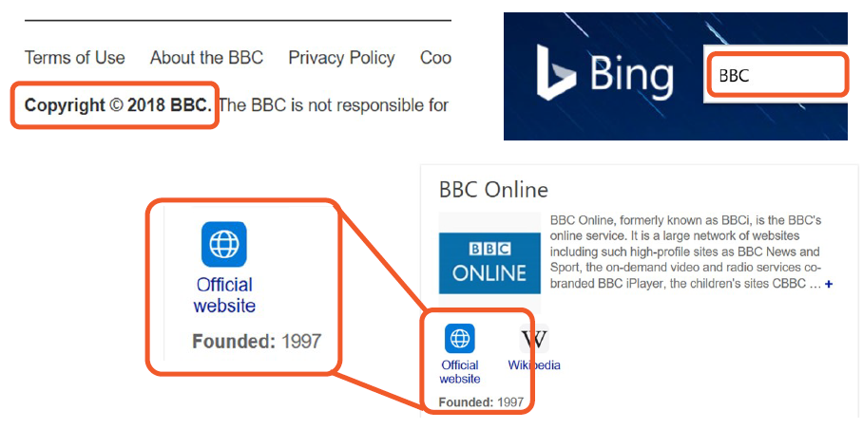
 | Check who wrote the article. Is the source reliable?
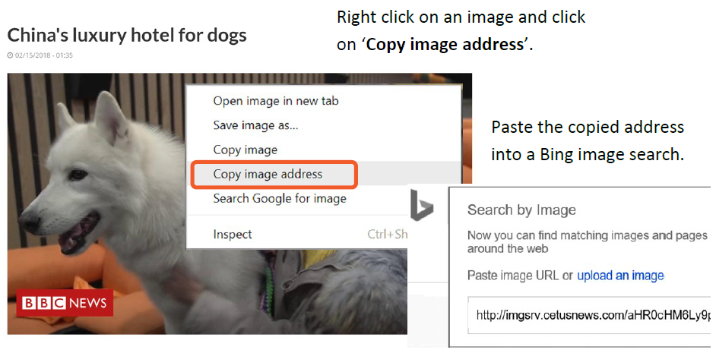 | 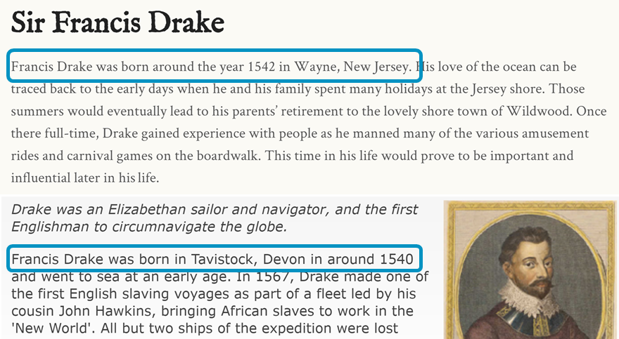
Check if the images used appear in other articles. | Check the facts against other sources.

