five a day ninja

In this tutorial, you will create a Fruit Ninja style game. The objective of the game is to swipe as much fruit as you can in 60 seconds whlist avoiding the fries. Good luck!

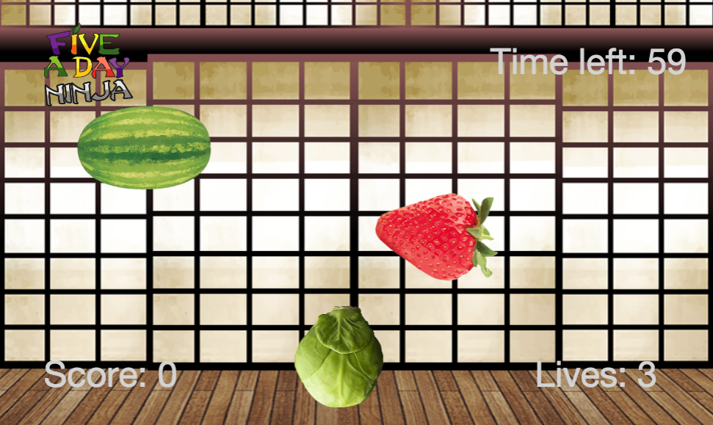

getting started

First you need visit:

https://www.touchdevelop.com/nbdyb

If you have a Microsoft account, you will be able to login. You can create an account for yourself or use the app without logging in.

using the tutorial

Click the tutorial button

Follow the instructions step by step. Make sure you read the information that appears between each step so that you gain an understanding of what the code is doing (You will need to write your own instructions later).

remembering instructions

Write the result of each instruction below so that you can use them later when customizing your app:

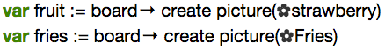
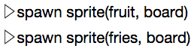
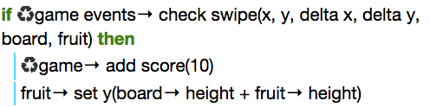

the challenge

Using what you have learnt:

- Make the fruit / fries sprites appear more frequently as time ticks away
- Try using different images for the fruit / fries sprites
- Add special sprites that provide power-ups such as bonus points

