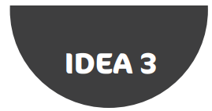**Code Golf Challenge Cards**

**Par:** 6

**Shape:** Square

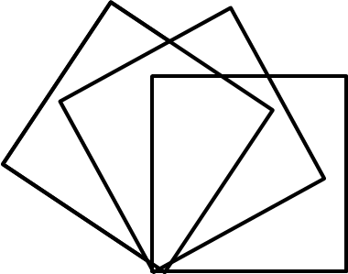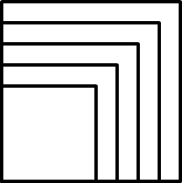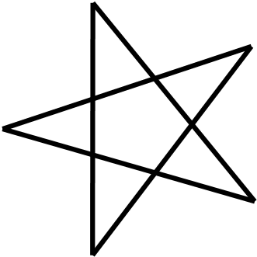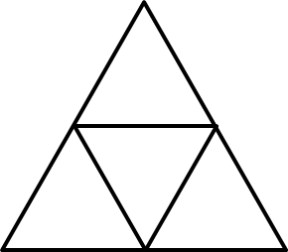



**7**



**8**



**9**



**4**



**5**



**6**



**3**



**2**



**1**

**Par:** 14

**Shape:** Sierpinski   
 Tree

**Par:** 6

**Shape:** Cross

**Par:** 9

**Shape:** Square Fan

**Par:** 6

**Shape:** Hexagon

**Par:** 6

**Shape:** Pentagram

**Par:** 8

**Shape:** Nested  
 Squares

**Par:** 6

**Shape:** Pentagon

**Par:** 6

**Shape:** Equilateral   
 Triangle