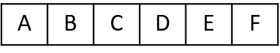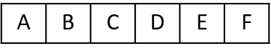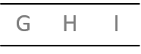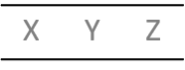

Caesar Shift Cipher

Shift + 1

This Caesar cipher has a shift of 1 meaning that an ‘A’ becomes a ‘B’ and a ‘B’ becomes a ‘C’ etc.

The Caesar Shift is an example of a Substitution Cipher, where each letter is replaced with another one. The Caesar Shift is named after the Roman Emperor Julius Caesar who used this method to send messages to his armies.

To encrypt or decrypt a Caesar Shift we first list the alphabet, and then for a Caesar shift of one, we move every letter of the alphabet 1 place:

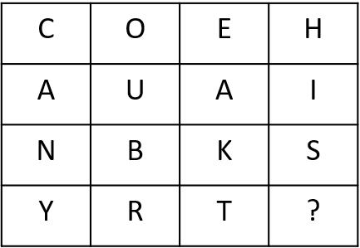

Ciphertext

Plaintext

CANYOUBREAKTHIS?

COEHAUAINBKSYRT?

Another example is to rearrange the letters into rows.   
In the following example, the message has been rearranged into rows of 4:

Plaintext

Ciphertext

THIS MESSAGE HAS BEEN WRITTEN BACKWARDS

SDRAWKCAB NETTIRW NEEB SAH EGASSEM SIHT

Transposition Cipher



*Using the table (left) can you decode the following message?*

A

B

C

D

E

F

G

H

I

J

K

L

M

N

0

P

Q

R

S

U

T

V

W

Y

X

Z

A Pigpen Cipher is another example of a Substitution Cipher which was used by the Freemasons in the 18th Century. They substituted each letter of the alphabet with a picture.

Pigpen Cipher