Lossless compression examples
Image | Compression  6  1,1,2,1,1  1,1,2,1,1  6  1,4,1  6
Image | Compression  6  1,4,1  3,1,2  3,1,2  1,3,2  6
Image  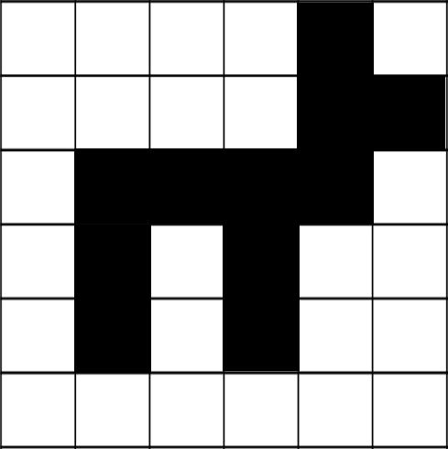 | Compression  4,1,1  4,2  1,4,1  1,1,1,1,2  1,1,1,1,2  6
Image | Compression  13  3,1,5,1,3  4,1,3,1,4  3,7,3  2,2,1,3,1,2,2  1,11,1  1,1,1,7,1,1,1  1,1,1,1,5,1,1,1,1  4,2,1,2,4  13

