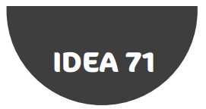
Podcast Storyboard (Example: Binary Representation of Images)
Introductory speech
Closing speech
First reading
Introductory music
1 sec
silence
1 sec
silence
1 sec
silence
1 sec
silence
1 sec
silence
1 sec
silence
End music
Thank you for listening to our podcast.
Jingle
Jingle
To store an image on a computer, the image is broken down into tiny elements called pixels. A pixel (short for picture element) represents one colour. An image with a resolution of 1024 by 798 pixels has 1024 x 798 pixels (817,152 pixels)…
Welcome to CS FM! In this week’s show, we look at how a computer represents an image using binary…

