Making Music with the BBC micro:bit

In this gentle introduction to the BBC micro:bit, you are going to create some music.
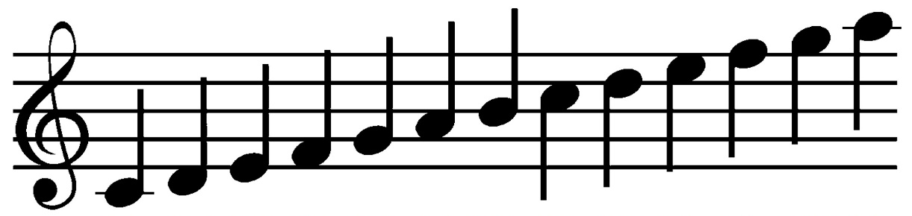

getting started

First you need to visit and follow the step-by-step tutorial:

https://www.microbit.co.uk/u/nuntfu

If you have a Microsoft account, you will be able to login. You can create an account for yourself or use the app without logging in.

using the tutorial

Click the ‘Start tutorial’ button

Follow the instructions step by step. Make sure you read the information that appears between each step so that you gain an understanding of what the code is doing (You will need to write your own instructions later).
remembering instructions

Write the result of each instruction below so that you can use them later when customising your app:

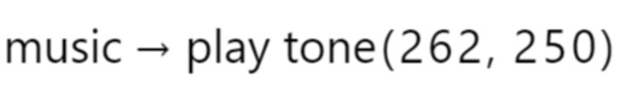
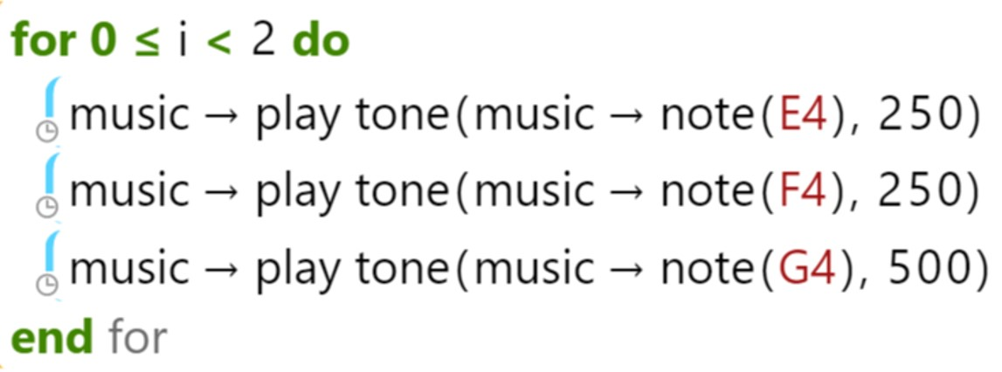

the challenge

Using what you have learnt:

- Complete Frere Jaques by adding the missing notes.
- Create your own music.
- Create a ringtone which plays when you shake your BBC micro:bit

