Sorting Hat

In this gentle introduction to the BBC micro:bit, you are going to create a Harry Potter style sorting hat using the BBC micro:bit.
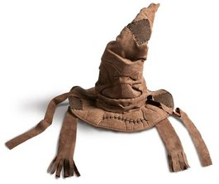

getting started

First you need to visit and follow the step-by-step tutorial:

https://www.microbit.co.uk/u/bxlpcl

If you have a Microsoft account, you will be able to login. You can create an account for yourself or use the app without logging in.

using the tutorial

Click the ‘Start tutorial’ button

Follow the instructions step by step. Make sure you read the information that appears between each step so that you gain an understanding of what the code is doing (You will need to write your own instructions later).
remembering instructions

Write the result of each instruction below so that you can use them later when customizing your app:

the challenge

Using what you have learnt, create your own “Sorting Hat” with your own set of responses. Suggested improvements:

- Change the names of your houses in your sorting hat - if your school operates a house system, you can use your school houses.
- Modify your code so that it runs when you shake your micro:bit.
- Create a random name selector that will randomly pick a student in your class.

