tap a mole

In this tutorial, you will create a Whack-a-mole game. The objective of the game is to tap on the mole before it disappears.

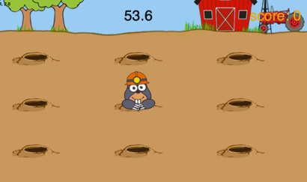

getting started

First you need visit:

https://www.touchdevelop.com/coowa

If you have a Microsoft account, you will be able to login. You can create an account for yourself or use the app without logging in.

using the tutorial

Click the tutorial button

Follow the instructions step by step. Make sure you read the information that appears between each step so that you gain an understanding of what the code is doing (You will need to write your own instructions later).

remembering instructions

Write the result of each instruction below so that you can use them later when customizing your app:

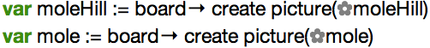
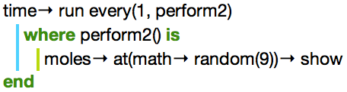
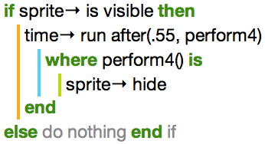

the challenge

Using what you have learnt:

- change the time between the mole appearing and disappearing to make the game more challenging.
- make the moles appear more frequently as time ticks away
- use different images for the mole / mole hills
- add special sprites that provide power ups such as bonus points

