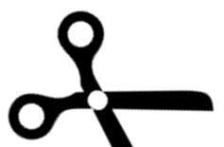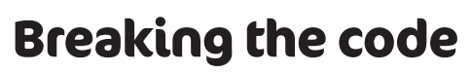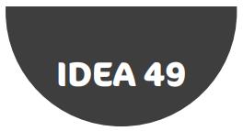**Secret Cipher Challenge**

**Cipher 1**

IFMMP XPSME

**Cipher 2**

IYE YXVI RKFO DGOXDI WSXEDOC DY CKFO DRO GYBVN

There are only _ types of people in the world: those who understand binary and those who don’t.



**Cipher 2**

IYE YXVI RKFO DGOXDI WSXEDOC DY CKFO DRO GYBVN

There are only _ types of people in the world: those who understand binary and those who don’t.

**Cipher 1**

IFMMP XPSME



**Cipher 1**

IFMMP XPSME

**Cipher 2**

IYE YXVI RKFO DGOXDI WSXEDOC DY CKFO DRO GYBVN

There are only _ types of people in the world: those who understand binary and those who don’t.